**Assignment 08 – Drupal 9 CMS Website (Basic Pages)**

**Instructions for completing template:**Replace **[bracketed red text]** with the requested information or screen capture.  
Replace **bracketed red text with black text** and then remove the brackets.  
Do not include full screen shot images, or full screen shots that are reduced in size. Use a snippet tool to capture parts of the screen and insert those images into the template.  
Do not remove tags from this template. Please answer all questions.  
**Please do not alter the formatting or delete parts of this template.**  
Assignment questions are not as detailed as activity questions.   
The assignment is where you demonstrate understanding of the material.

**Part A: Student Information**

1. **Student Name: [STUDENT NAME – Aamir, Patel] [A01]**
2. **Student Email: [STUDENT Email: - aamir8567@gmail.com] [A02]**
3. **Student Cell: [STUDENT Cell: - (872) 985 4361] OPTIONAL**
4. **What day and date did you start this assignment: [3/3/2021] [A03]**

**Go back to the instructions and begin work on part B.  
  
Part B: Create 1 Shared Web Host, Localhost or PaaS Drupal 8-9 Website**

(1) Shared Web Host Drupal 9 CMS Site Information:

1. Shared Web Host Name: [ NameCheap] [B01]  
   Shared Web Host Site Admin Username: [ aamir8567 ] [B02]   
   Shared Web Host Site Admin Password: [ Kamboli90123! ] [B03]  
   Domain Name: [ Namecheap.com] [B04]  
     
   Website Admin Username: [aapadcpate] [B05]  
   Website Admin Password: [9aIwR@LZB%#uk9Fgh3] [B06]  
   Database Name: [ drup989 ] [B07]  
   Table Prefix: [ dreo_ ] [B08]  
   Drupal CMS Website URL: [ <https://aamirpatel.tech/mod08assign08/> ] [B09]  
   Drupal version built (version.minor.patch): [ 9.1.4 ][B10]

**-OR-**

1. Localhost - Acquia Dev Desktop web host Drupal 9 site information [B01-D]
   1. Drupal major.minor.patch version built: [ Drupal version here ]
   2. **Site name:** [site name here]
   3. **Site email address:** [email address here]
   4. **Site Username:** [website username here]
   5. **Site Password:** [website password here ]

-OR-

(2) Pantheon – Drupal 8-9 CMS Site Information: Drupal 8 if 9 not supported

**Drupal Version Built (major.minor.patch): [Drupal version here]**

**Assignment Website Site Name:** **[Site Name here] [B01]**

**WEBSITE Admin Username:** **[Admin Username here] [B02]**

**WEBSITE Admin Password:** **[Admin Password here] [B03]**

**Pantheon Frontend Website URL:** **[Frontend website URL here] [B04]**

**Go back to the instructions and begin work on part C.  
  
Part C: Harden Shared Web Host, Localhost or PaaS Drupal Site**

1. SCREEN CAPTURE of the backend Admin toolbar > Configuration > Account settings, with the REGISTRATION AND CANCELATION section visible **[C01]**  
   **[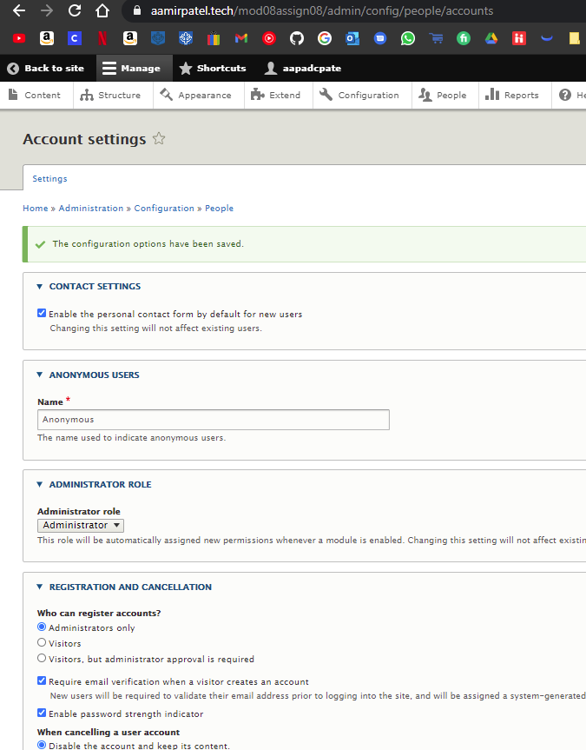]**
2. Screen capture of the Drupal 8 front-end website > User login page **[C02]**  
   **[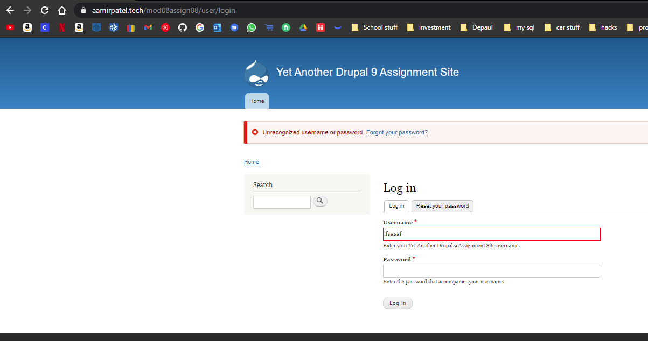]**

**Go back to the instructions and begin work on part D.**

**Part D: Answer Template Questions [D]**

**Based on topics covered in IT320 Module 07 and Module 08**

1. What is the purpose of Published check box on the Administration Basic page and Article content template pages? [D01]  
   **[** The purpose of the published check box in content template, is to make publishing of the content default, so you don’t have to go back and select publish everytime.**]**
2. What are the steps to add a new user to a Drupal 8-9 site? [D02]  
   **[** Admin ToolBar > People > add User > fill out the form > Create New account.**]**
3. What are the steps for finding, validating, installing, and activating a new DEFAULT Drupal 8-9 front-end client-facing theme? [D03]  
   **[**

* find a theme you like
* Check if it supports your version of drupal.
* Make sure it has a stable release.
* Check for dependencies
* Check for issues
* Check reviews
* Check reported site usage.

**]**

1. What are the steps for finding, validating, installing, and activating a new Drupal 8-9 back-end administration theme? [D04]  
   [

* find a theme you like
* Check if it supports your version of drupal.
* Make sure it has a stable release.
* Check for dependencies
* Check for dependencies
* Check for issues
* Check reviews
* Check reported site usage.]

1. What are the names of the three (3) types of Drupal modules? [D05]  
   [Core Modules, Contributed Modules, Custom Modules.]
2. What are the names of the 3 files used to create a Drupal 8-9 custom module? [D06]  
   [

* module_name. info. yml
* module_name. routing. yml
* module_name_Controller. php

]

1. If a Drupal module project page has the following Requires Drupal [ ^8 || ^9 ] what versions of Drupal can it be installed on? [D07]  
   [ This means it supports all versions of Drupal 8 and Drupal 9, And it requires your webpage to be either Drupal 8 or Drupal 9.]
2. If a Drupal module project page has the following Requires Drupal [ ^8.8 || ^9.0.1] what versions of Drupal can it be installed on? [D08]  
   [ In this case, you can not install anything below Drupal 8 ( < Drupal 8.8), and no Drupal 9.0.0 aswell. ]
3. If a Drupal module project page has the following Requires Drupal [ 7.x] what versions of Drupal can it be installed on? [D09]  
   [It can be installed on all versions about Drupal 7, so Drupal 7.x.x Drupal 8.x.x and Drupal9.x.x]
4. If a Drupal module project page has the following Requires Drupal [ 8.x] what versions of Drupal can it be installed on? [D10]  
   [It can be installed on all versions about Drupal 8, so Drupal 8.x.x and Drupal9.x.x]

**Go back to the instructions and begin work on part E.**

**Part E -** Extend the Shared (or PaaS) Drupal 8-9 Site with Core Modules

**1. SCREEN CAPTURE of the backend list of Admin toolbar > Extend with Telephone module enabled and visible.   
[E01]  
[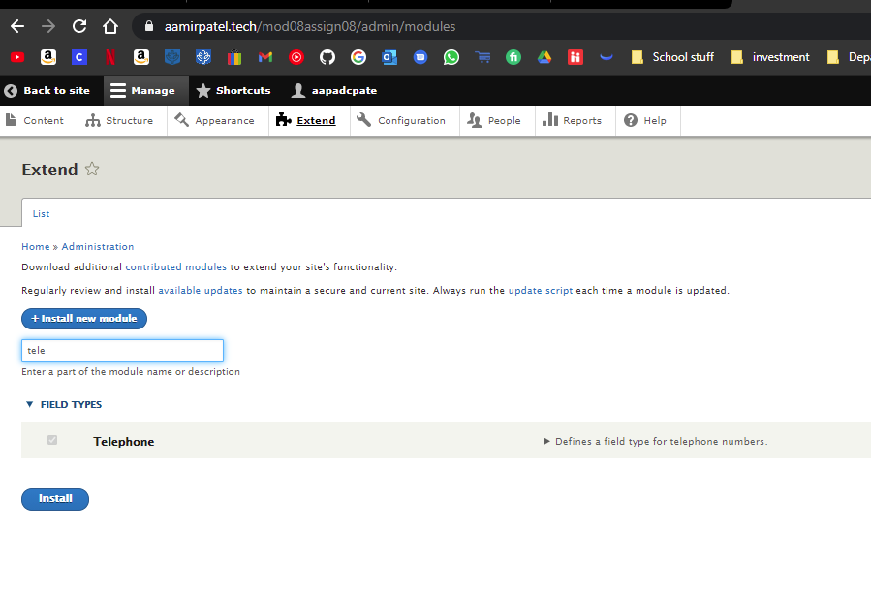]**

**2. SCREEN CAPTURE of the backend of Admin toolbar > Structure > Content types > My telephone test   
[E02]  
[Edit,**

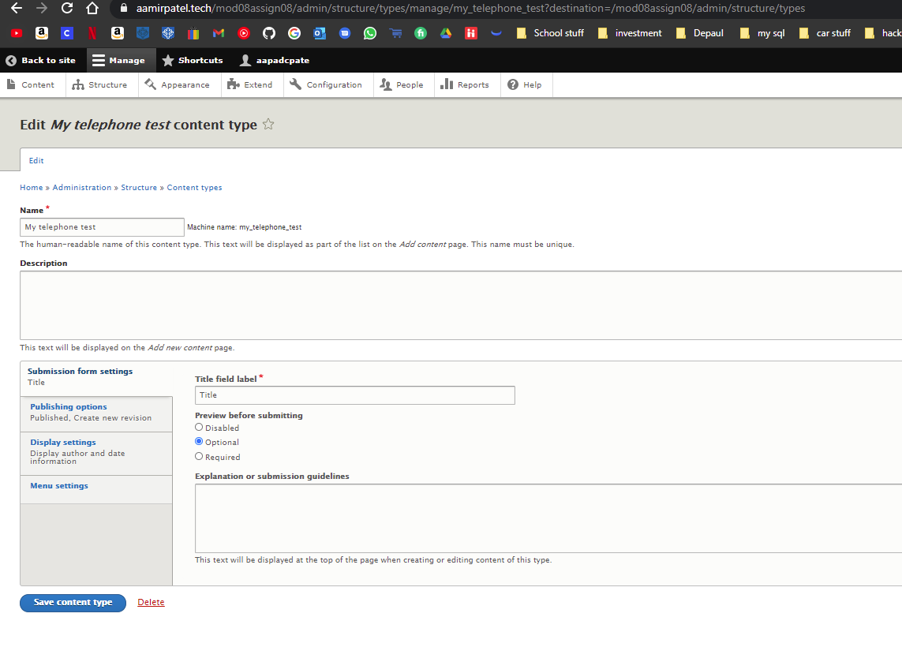

**Manage Fields,**

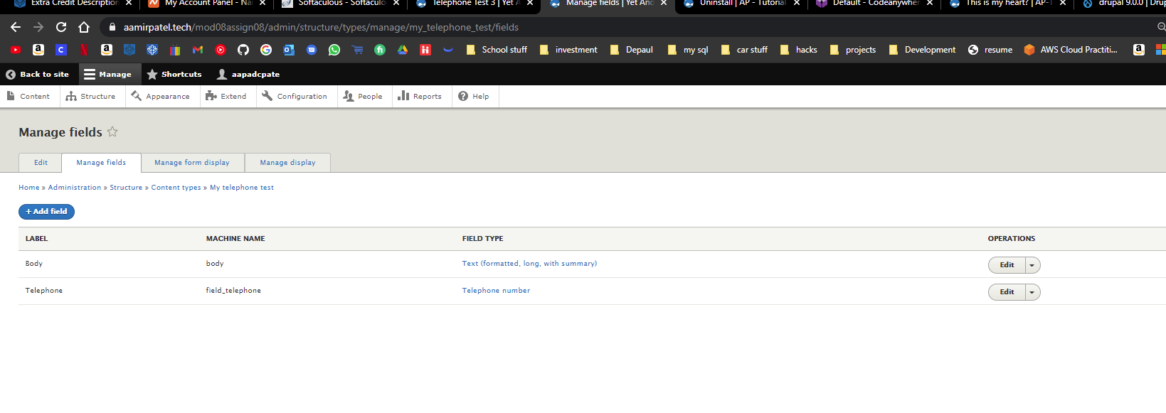

**Manage form display**

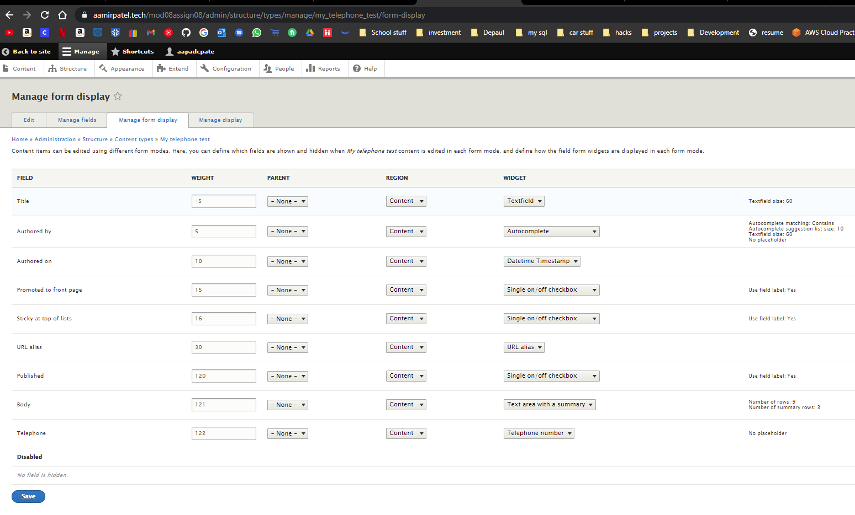

**and Manage display**

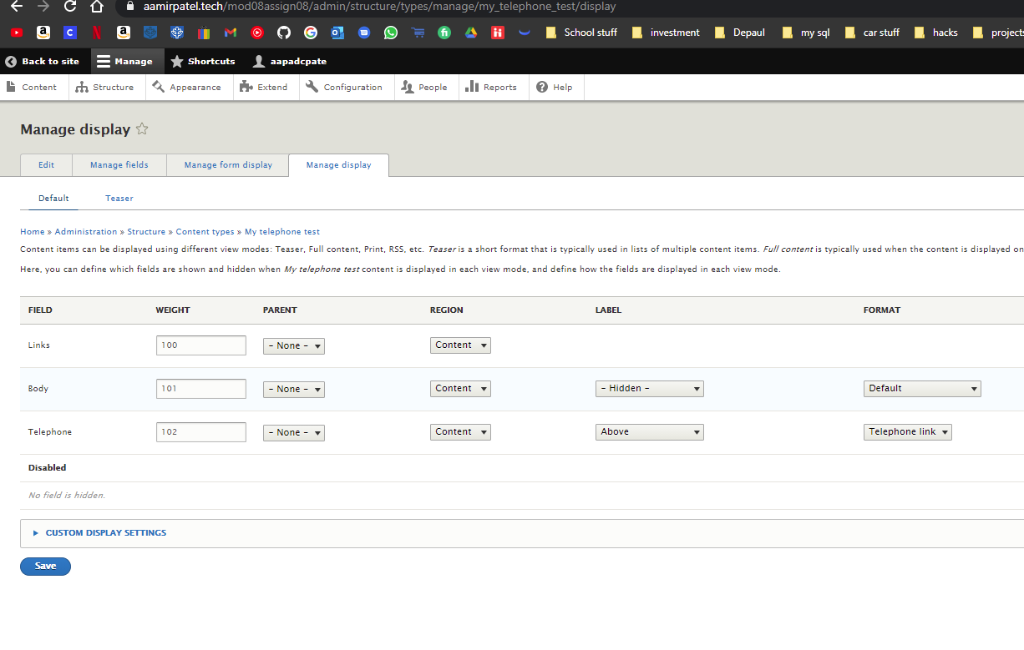

**]**

**3. SCREEN CAPTURE of the backend of Admin toolbar > Content, filtering for ‘My telephone test’ Content type [E03]  
[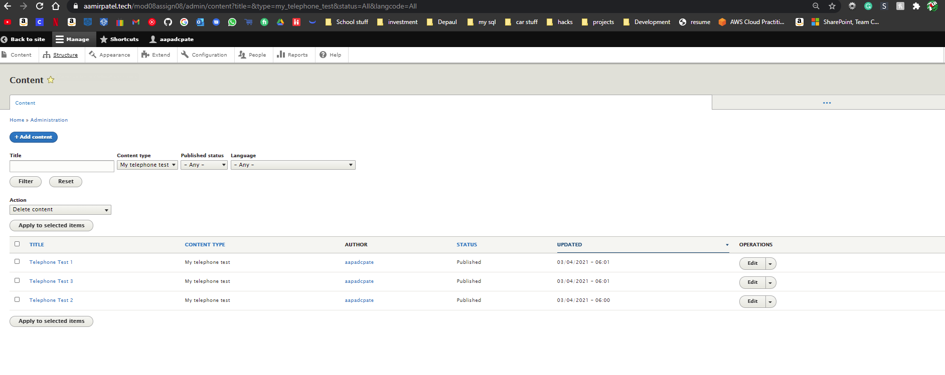]**

**4. SCREEN CAPTURE of the front-end website, as an anonymous user** after selecting the Main navigation link for one of the three (3) “My telephone test” menu items **[E04]  
[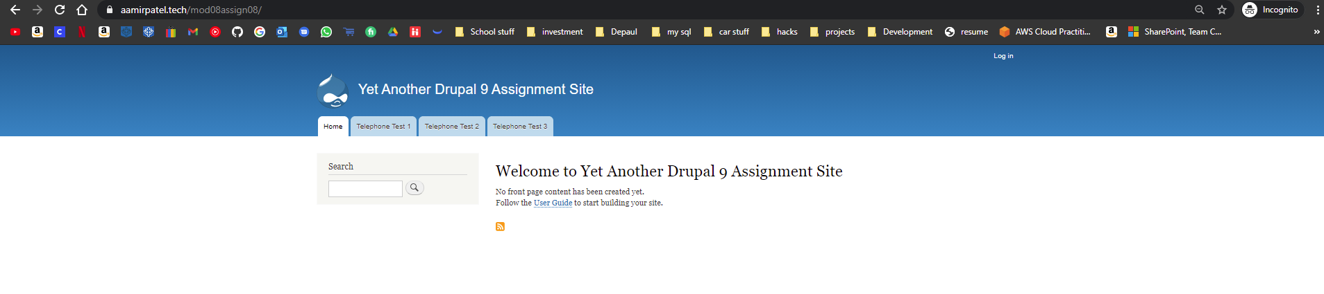]**

Part F – Create a new Codeanywhere Drupal 9 site

Drupal 9 Version Info:

1. Which website URL did you use to determine the most recent version of Drupal 9? **[F01]** **[**

* https://www.drupal.org/project/drupal/releases
* https://www.drupal.org/project/drupal

]

1. Which version of Drupal 9 did you select from the above website when you build the Drupal 9 site on your Codeanywhere account?   
   **[F02]**   
   **[** Drupal 9.1.4**]**
2. Did you harden your Drupal 9 site on Codeanywhere? **[F03]**   
   **[Yes]**

Codeanywhere account info: (So your instructor can login to your account and start the container connection)

1. **Codeanywhere account Username (email): [F04]** **[** Mpate180@depaul.edu **]**
2. **Codeanywhere account Password:** **[F05] [** Kamboli1! **]**

Codeanywhere Drupal 9 Website Info:  
(So your instructor can login to your Drupal site as the site admin)

1. **Drupal 9 CMS Website URL:** **[F06] [**http://ap-assignment-08-mpate18024699.codeanyapp.com/**]**
2. **Website Admin Username:** **[F07] [** aapadcpate **]**
3. **Website Admin Password:** **[F08] [** 9aIwR@LZB%#uk9Fgh3 **]**

**Go back to the instructions and begin work on part G.**

Part G - Extend the Codeanywhere Drupal 9 Site with a Custom Module

1. SCREEN CAPTURE of the Codeanywhere file system, showing the Modules folder expanded and the custom module folder fully expanded  
   **[G01]**

**[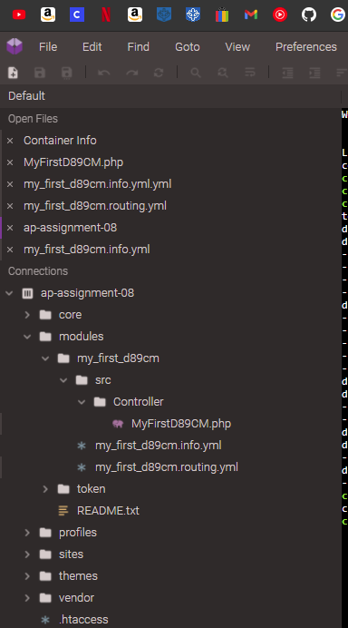]**

1. File name and SCREEN CAPTURE of your custom module info.yml file contents using an ASCII editor  
   **[G02]  
   [** my_first_d89cm.info.yml **]**

**[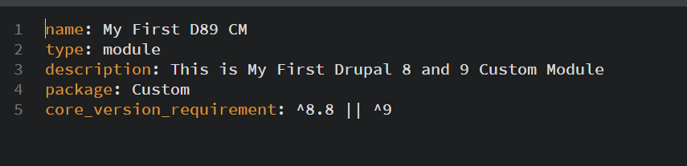]**

1. File name and SCREEN CAPTURE of your routing.yml file contents using an ASCII editor  
   **[G03]  
   [** my_first_d89cm.routing.yml **]**

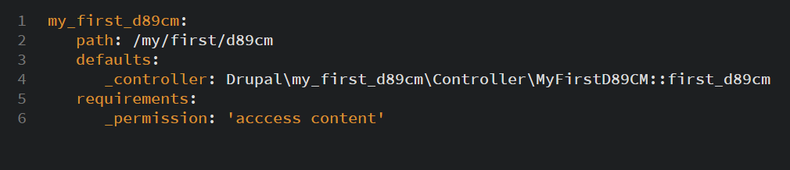**]**

1. Controller file name and SCREEN CAPTURE of your Controller file contents using an ASCII editor  
   **[G04]  
   [** MyFirstD89CM.php **]**  
   **[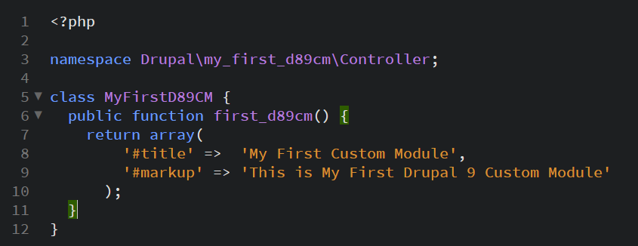]**
2. While logged into the Drupal 9 site, Access the custom plugin by adding its path to the end of the site URL then take a SCREEN CAPTURE of Drupal site   
   **[G05]**  
   **[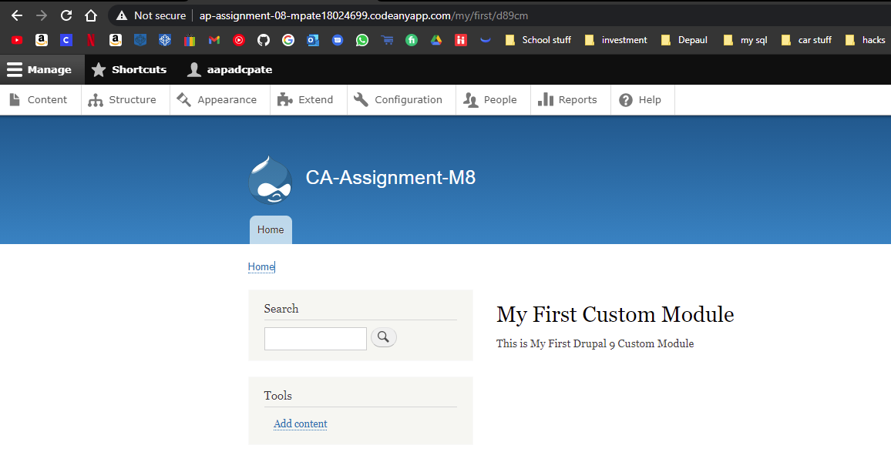]**

**Go back to the instructions and begin work on part H.**

**Part H – Assignment Wrap up: (REQUIRED)**

Answers to questions 1-3 are required to receive points for this section.

1. **Did you work with a tutor or volunteer on this assignment?   
   [H01]  
   [**No**]**
2. **Did you have any problem or issues completing this assignment?   
   [H02]  
   This is not an optional question.   
   [**No**]**
3. **If you answered yes for #2 above, please elaborate and be specific about the issues or problems you had (other than time management)  
   If you had trouble with a specific section, part, or question, please identify it by number and explain what you did not understand or had problems with below.   
   [H04]   
   *Required if you answered Yes above – Otherwise optional  
   [**N/a**]**
4. **If you answered yes for #2 above, did you contact the instructor or tutor for help and if not, your reasons why?   
   [H03]  
    [**N/A**]**